A Recipe For:

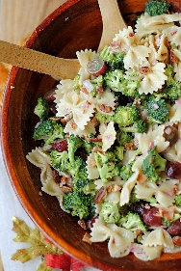 

# Broccoli Grape Harvest Salad

**From the Kitchen of:** Mom

**Servings:** A group

**Prep Time:** 20 minutes **Bake Time:** **Bake Temp:**

**Ingredients:**

* ½ (16 oz) box of whole wheat bowtie pasta
* 1 lb fresh broccoli
* ½ cup lite may
* ½ cup non-fat plain yogurt
* 1/3 cup sugar
* 1/3 cup diced red onion
* 1/3 cup red wine vinegar
* 1 tsp salt
* 2 cups seedless red grapes
* 6 cooked turkey bacon slices, crumbled
* ¼ cup chopped pecans

**Instructions:**

1. Preheat oven to 350 degrees. Bake pecans in a single layer in a shallow pan for about 6 minutes until lightly toasted and fragrant, stirring halfway through. The prepare pasta according to package directions.
2. Cut broccoli florets from stems and separate into small pieces using a paring knife. In a large bowl, whisk together mayo, yogurt, sugar, onion, vinegar and salt and toss with broccoli, hot cooked pasta and grapes. Stir to coat.
3. Cover and shill for up to 3 hours. Stir in bacon and toasted pecans just before serving.